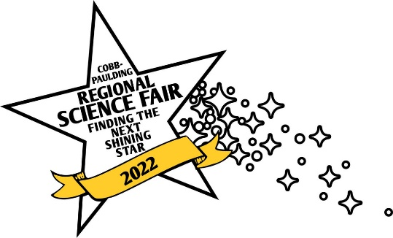
2022 Cobb/Paulding Regional Science & Engineering Fair
Registration and Application Instructions

Dear Student,

In order to advance to the Cobb/Paulding Regional Science Fair as a private, charter, or home-school student, you must compete in a local school Science Fair. In order to compete in this year’s Regional Science Fair please complete each of the following tasks:

1.) Please email Christian.cali@cobbk12.org for the time, location and director of the nearest local fair. You must compete and qualify at this fair, in order to participate in the Cobb Paulding Regional Science Fair.

2.) After qualifying for the Cobb/Paulding Regional Fair, you must register on-line by going to https://rocketjudge.com/register/XcRmobpV and completing the on-line registration form. In order to do so, you will need to know the title of your project, a parent/guardian’s e-mail, your science teacher’s e-mail, and a few details about your project. If needed, seek the help of your science teacher in order to complete the form. The deadline for on-line registration is Wednesday, January 19th, 2022.
3.) In addition, you must submit photocopies of the appropriate forms for your project to your school’s Science Fair Coordinator* by Friday, January 14th, 2022 (found at https://www.georgiacenter.uga.edu/sites/default/files/gsef-2022-forms-guide-checklist.pdf). These forms should have been completed before the start of your research.
Please keep the originals in your possession. You will also need to bring an additional set of photocopies of these forms to the Regional Science Fair to keep in a 3-ring binder at your exhibit.

A confirmation/information email for each participating student will be sent to the e-mail addresses listed (student and parent) on the online registration form by Thursday, January 27th. It will include the details and directions for the science fair.

Thank you for your hard work in planning and presenting this research project. We look forward to seeing you on Saturday, January 29th.

Good luck,

Dawn Hudson, Science Fair Director
Christian Cali, Science Fair Co-Director
Tammy Brown, Science Fair Co-Director
Alana Davis, Science Fair Co-Director

*If you are a home-schooled student and therefore do not have a school Science Fair Coordinator, please email Christian.cali@cobbk12.org for more information.

