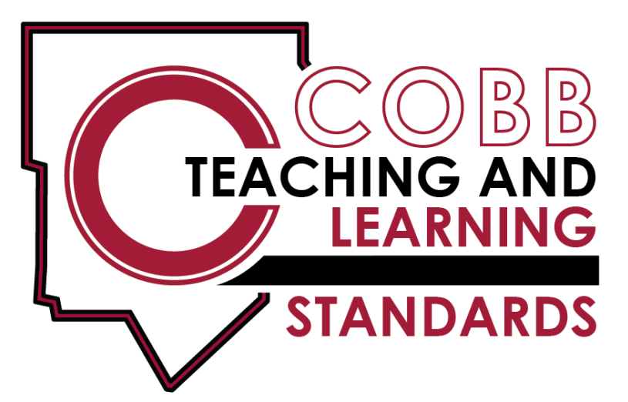

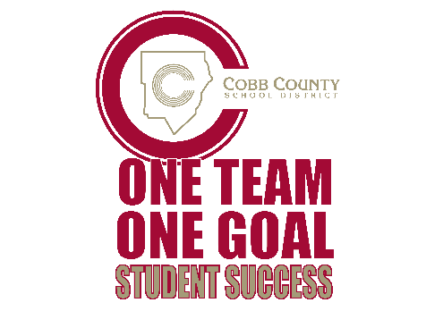
5th Grade Science
Cobb County School District 2017-2018
5th Grade Science Teaching & Learning Framework
Quarter 1 | Quarter 2 |  | Quarter 3 |  | Quarter 4
Unit 1  9 weeks | Unit 2  6 weeks | Unit 3  6 weeks |  | 6 weeks  6 weeks | Unit 5  3 weeks | Unit 6  3 weeks | Review/ Enrich  2 weeks
Constructive and Destructive Forces | Physical and Chemical Changes | Electricity and Magnetism |  | Cells and Microorganisms | Classification of Organisms | Inherited Traits and Learned Behaviors | Milestone Preparation
S5E1. Obtain, evaluate, and communicate information to identify surface features on the Earth caused by constructive &/or destructive processes.  a. Construct an argument supported by scientific evidence to identify surface features as being caused by constructive &/or destructive processes.  b. Develop simple interactive models to collect data that illustrate how changes in surface features are/were caused by constructive &/or destructive processes.  c. Ask questions to obtain information on how technology is used to limit &/or predict the impact of constructive & destructive processes. | S5P1. Obtain, evaluate, and, communicate information to explain the differences between a physical change & a chemical change.  a. Plan & carry out investigations by manipulating, separating, & mixing dry & liquid materials & communicate collected data to demonstrate examples of physical change.  b. Construct an argument based on observations that the physical changes in the state of water are due to temperature differences, which cause small particles that cannot be seen to move differently.  c. Plan & carry out an investigation to determine if a chemical change occurred based on observable evidence.  (color, gas, temperature change, odor, new substance produced). | S5P2. Obtain, evaluate, and communicate information to investigate electricity.  a. Obtain & combine information from multiple sources to explain the difference between naturally occurring electricity (static) & human-harnessed electricity.  b. Design a complete, simple electric circuit, & explain all necessary components.  c. Plan and carry out investigations on common materials to determine if they are insulators or conductors of electricity. | S5P3. Obtain, evaluate and communicate information about magnetism & its relationship to electricity.  a. Construct an argument based on experimental evidence to communicate the differences in function & purpose of an electromagnet & magnet.  b. Plan & carry out an investigation to observe the interaction between a magnetic field and a magnetic object. | S5L3. Obtain, evaluate, and communicate information to compare and contrast the parts of plant and animal cells.  a. Gather evidence by utilizing technology tools to support a claim that plants and animals are comprised of cells too small to be seen without magnification.  b. Develop a model to identify and label parts of a plant cell (membrane, wall, cytoplasm, nucleus, chloroplasts) and of an animal cell (membrane, cytoplasm, and nucleus).  c. Construct an explanation that differentiates between the structure of plant and animal cells.  S5L4. Obtain, evaluate and communicate information about how microorganisms benefit or harm larger organisms.  a. Construct an argument using scientific evidence to support a claim that microorganisms are beneficial  b. Construct an argument using scientific evidence to support a claim that microorganisms are harmful. | S5L1.  Obtain, evaluate and communicate information to group organisms using scientific, classification procedures.  a. Develop a model that illustrates how animals are sorted into groups and how vertebrates are sorted into groups using data from multiple sources.  b. Develop a model that illustrates how plants are sorted into groups using data from multiple sources | S5L2.  Obtain, evaluate and communicate information showing that some characteristics of organisms are inherited & other characteristics are acquired.  a. Ask questions to compare & contrast the characteristics of instincts & learned behaviors.  b. ask questions to compare & contrast inherited & acquired physical traits.
Fifth Grade Standards

The Cobb Teaching and Learning Standards (CT & LS) are designed to provide foundational knowledge and skills for all students to develop proficiency in science. The Project 2061’s Benchmarks for Science Literacy and the follow up work, A Framework for K-12 Science Education were used as the core of the standards to determine appropriate content and process skills for students. The Science Georgia Standards of Excellence focus on a limited number of core disciplinary ideas and crosscutting concepts which build from Kindergarten to high school. The standards are written with the core knowledge to be mastered integrated with the science and engineering practices needed to engage in scientific inquiry and engineering design. Crosscutting concepts are used to make connections across different science disciplines.
The Cobb Teaching and Learning Standards drive instruction. Hands-on, student-centered, and inquiry-based approaches should be the emphasis of instruction. The standards are a required minimum set of expectations that show proficiency in science. However, instruction can extend beyond these minimum expectations to meet student needs. At the same time, these standards set a maximum expectation on what will be assessed by the Georgia Milestones Assessment System.
Science consists of a way of thinking and investigating, as well a growing body of knowledge about the natural world. To become literate in science, students need to possess sufficient understanding of fundamental science content knowledge, the ability to engage in the science and engineering practices, and to use scientific and technological information correctly. Technology should be infused into the curriculum and the safety of the student should always be foremost in instruction.
The Fifth Grade, Cobb Teaching and Learning Standards for science engage students in investigations of scientific concepts. Students are active learners and use hands-on activities to discover and explain phenomena. They understand that science is a process for gaining knowledge about the natural world and are able to conduct experiments and report their findings in the form of written reports, charts, and various other presentations including multi-media projects. Their scientific explanations emphasize evidence and begin to use scientific principles, models, and theories.

Fifth graders keep records of investigations and observations and understand why they should not alter records. They use numerical data to describe and compare objects, convert the fractions to decimals in scientific calculations, and identify the largest and smallest possible value of something. They use reference books, magazines or newspapers, and computer databases to locate scientific information.

Students at this grade level are able to identify the causes of some of Earth’s surface features, explain the difference between a physical and a chemical change, investigate electricity and magnetism and the relationship between them, use scientific procedures to classify organisms, understand the difference between behaviors and traits, contrast the parts of animal and plant cells, and argue from evidence on how microorganisms can be beneficial or harmful to other organisms.

Earth Science

S5E1. Obtain, evaluate, and communicate information to identify surface features on the Earth caused by constructive &/or destructive processes.

a. Construct an argument supported by scientific evidence to identify surface features (examples could include deltas, sand dunes, mountains, volcanoes)
as being caused by constructive &/or destructive processes (examples could include deposition, weathering, erosion, and impact of organisms).

b. Develop simple interactive models to collect data that illustrate how changes in surface features are/were caused by constructive &/or destructive processes.

c. Ask questions to obtain information on how technology is used to limit &/or predict the impact of constructive & destructive processes.
(Clarification statement: Examples could include seismological studies, flood forecasting (GIS maps), engineering/construction methods & materials, & Infrared/
satellite imagery.)

Physical Science

S5P1. Obtain, evaluate, and, communicate information to explain the differences between a physical change & a chemical change.
a. Plan & carry out investigations of physical changes by manipulating, separating, & mixing dry and liquid materials.
b. Construct an argument based on observations to support a claim that the physical changes in the state of water are due to temperature differences, which cause small particles that cannot be seen to move differently.
c. Plan & carry out an investigation to determine if a chemical change occurred based on observable evidence (color, gas, temperature change, odor, new substance produced).
S5P2. Obtain, evaluate, and communicate information to investigate electricity.

a. Obtain & combine information from multiple sources to explain the difference between naturally occurring electricity (static) and human-harnessed electricity.

b. Design a complete, simple electric circuit, & explain all necessary components.
c. Plan and carry out investigations on common materials to determine if they are insulators or conductors of electricity.

Physical Science (continued)

S5P3. Obtain, evaluate, and communicate information about magnetism & its relationship to electricity.
a. Construct an argument based on experimental evidence to communicate the differences in function & purpose of an electromagnet & magnet.
(Clarification statement: Function is limited to understanding temporary & permanent magnetism)

b. Plan and carry out an investigation to observe the interaction between a magnetic field and a magnetic object.
(Clarification statement: The interaction should include placing materials of various types (wood, paper, glass, metal, and rocks) and thickness between the magnet and the
magnetic object.)

Life Science

S5L1. Obtain, evaluate, and communicate information to group organisms using scientific, classification procedures.
a. Develop a model that illustrates how animals are sorted into groups (vertebrate & invertebrate) and how vertebrates are sorted into groups (fish, amphibians, reptiles, bird, & mammal) using data from multiple sources.
b. Develop a model that illustrates how plants are sorted into groups (seed producers, non-seed producers) using data from multiple sources.

S5L2. Obtain, evaluate, and communicate information showing that some characteristics of organisms are inherited and other characteristics are acquired.

a. Ask questions to compare and contrast the characteristics of instincts and learned behaviors.

b. Ask questions to compare and contrast inherited and acquired physical traits.
(Clarification statement: Punnett squares & genetics are taught in future grades.)

Life Science (continued)

S5L3. Obtain, evaluate, and communicate information to compare and contrast the parts of plant & animal cells.
a. Gather evidence by utilizing technology tools to construct an explanation that plants & animals are comprised of cells too small to be seen without magnification.
b. Develop a model to identify & label parts of a plant cell (membrane, wall, cytoplasm, nucleus, chloroplasts) and of an animal cell (membrane, cytoplasm & nucleus).
c. Construct an explanation that differentiates between the structure of plant & animal cells.

S5L4. Obtain, evaluate and communicate information about how microorganisms benefit or harm larger organisms.
(Clarification statement: Possible microorganisms could include Tardigrades, Lactobacillus, Probiotics, Rotifers, Salmonella, Clostridium botulinum (Botox), E-coli,
Algae, etc. Students are not expected to know these specific organisms. The list is provided to give teachers examples.)

a. Construct an argument using scientific evidence to support a claim that microorganisms are beneficial.

b. Construct an argument using scientific evidence to support a claim that microorganisms are harmful.

